DIGIOTAI’S Step by step guide to Monitor the cold Storage temperature and humidity from DHT11 sensor with Raspberry Pi in a logistics environment in a supply chain management scenario using Firebase console and MIT App Inventor

Step 1 Setting up the Firebase Database

Firebase console is a One Platform to Build Mobile Apps, Improve Their Quality, And Grow Your Users. Types: iOS, Android, Web, C++, Unity.

Firstly, go to <https://firebase.google.com/> then the following window appears

Log in credentials: [Madhu.k@digiotai.com](mailto:Madhu.k@digiotai.com)

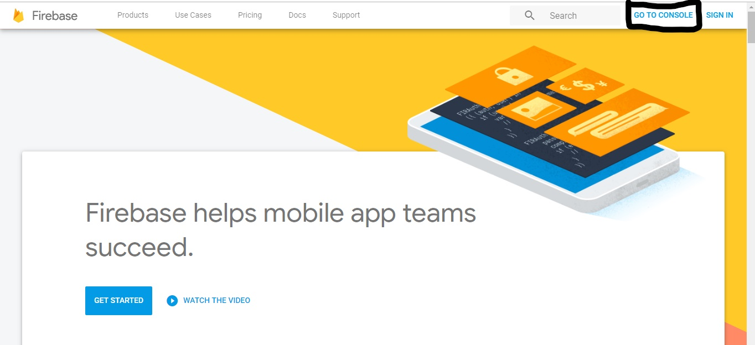

Click on Go to Console

Then the Sign-in page appears as shown in below

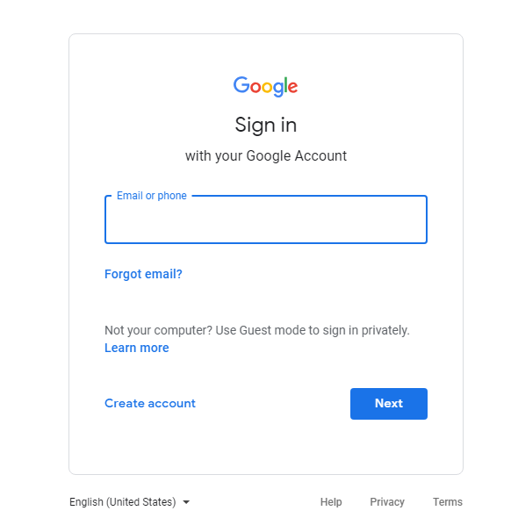

asks to sign in to Google accounts. Give access to your Google account

After Sign-in in to account you will be prompted to the console page. Here you have to add your project to store your data in Firebase Database. Click on + sign to Start your Project

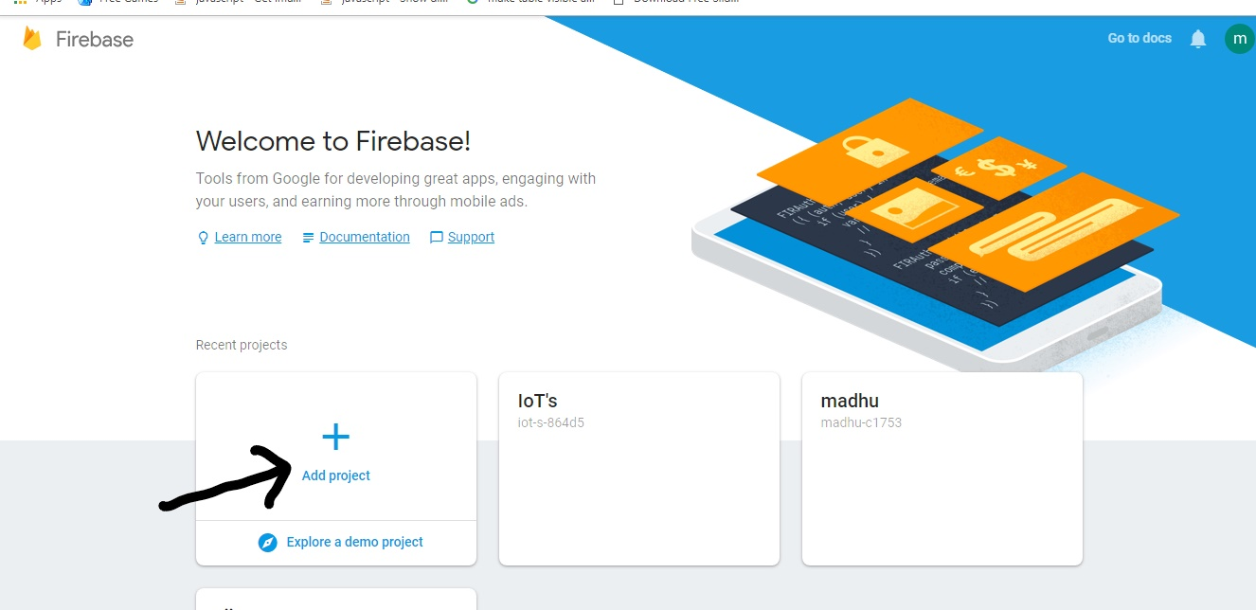

Then You will Be prompted to another window where you have to give a name to the project. Click on Create Project

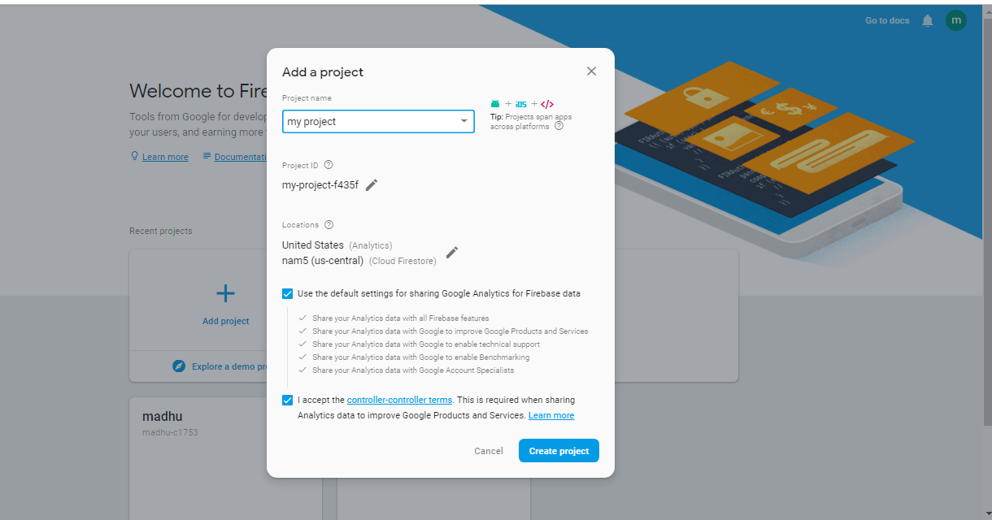

Once clicked on create project your project is created and it will be shown below

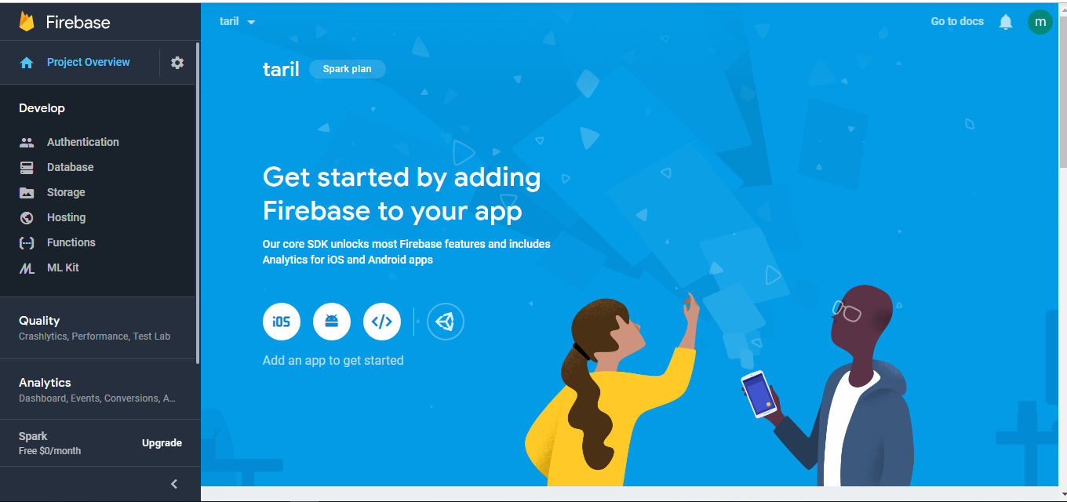

Before Using the Firebase Database, you should have following Prerequisites

• A server running Python 2.7+ or 3.x (which is default in Raspberry pi)

• Need a Firebase project (you have created it Already)

• A service account to communicate with the Firebase service

• configuration file with your service account's credentials.

Creating a Service Account

Now Click on Project Overview and go to Project Settings

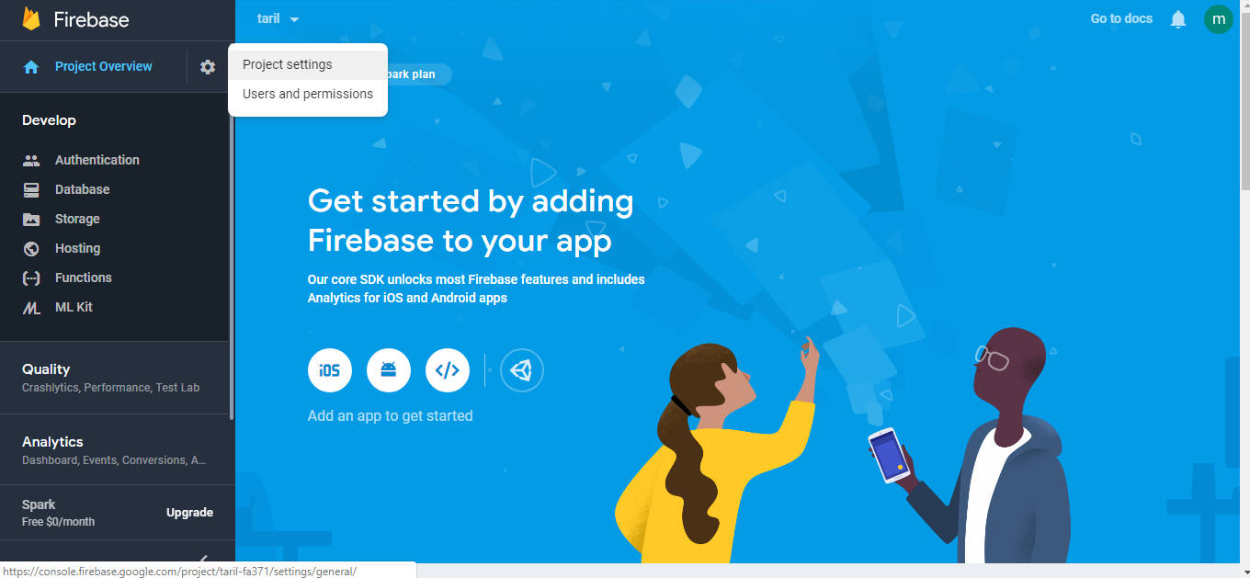

Navigate to the Service Accounts tab in your project's settings page

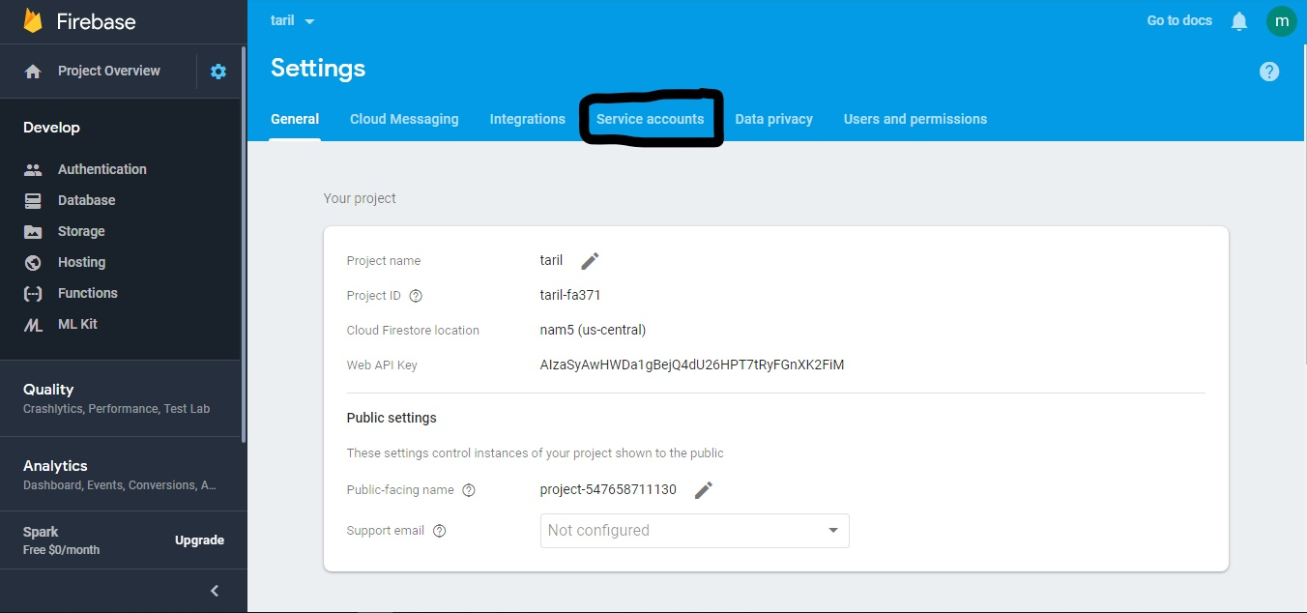

Chose the Language and Click the Generate New Private Key button at the bottom of the Firebase Admin SDK section of the Service Accounts tab.

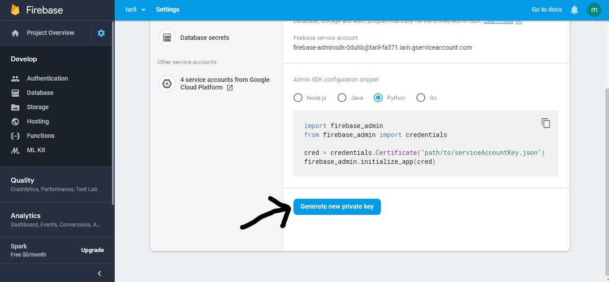

After you click the button, a JSON file containing your service account's credentials will be downloaded. You'll need this to initialize the SDK in the next step.

Click on Database you will be prompted to your Database Window. Now click on Real time Base

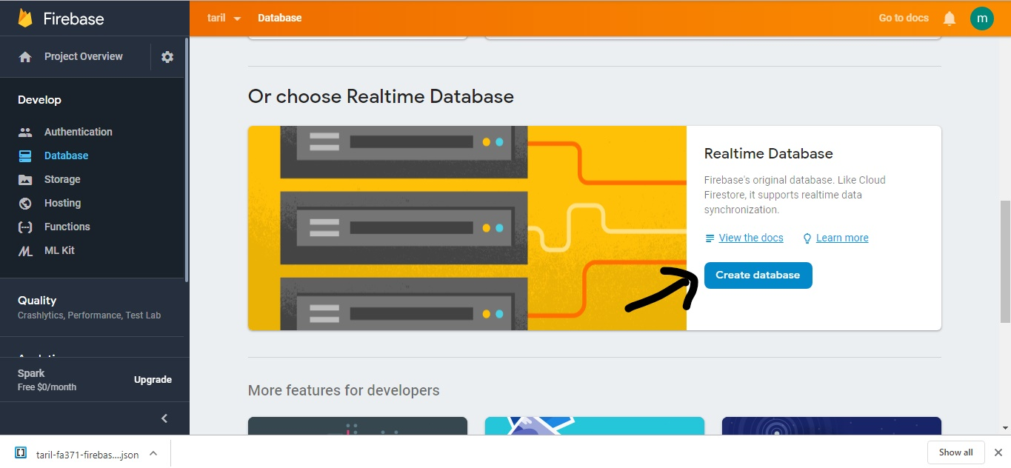

Once click on Create Database you will navigate to the following page

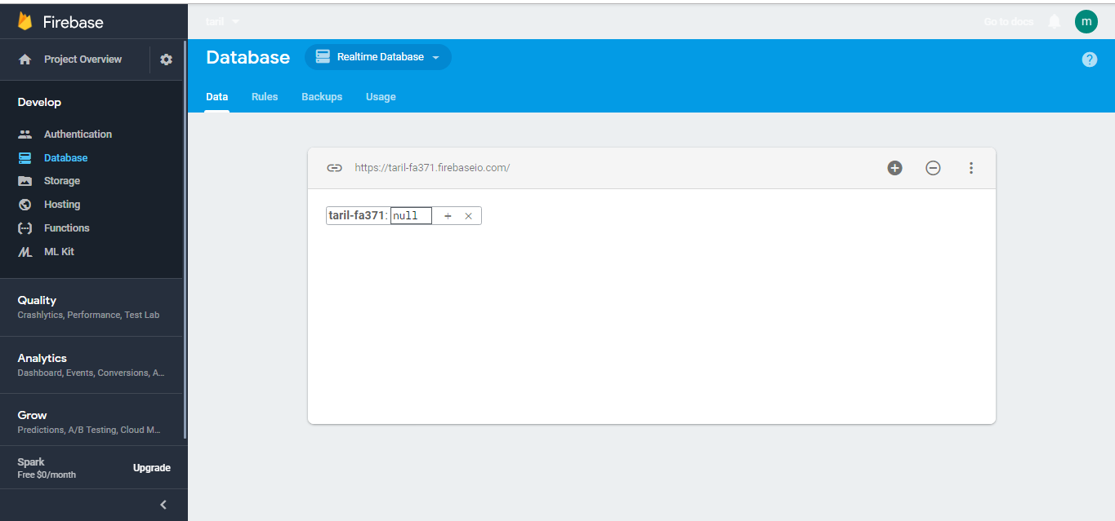

Then go to rules and change the rules to true and publish the rules

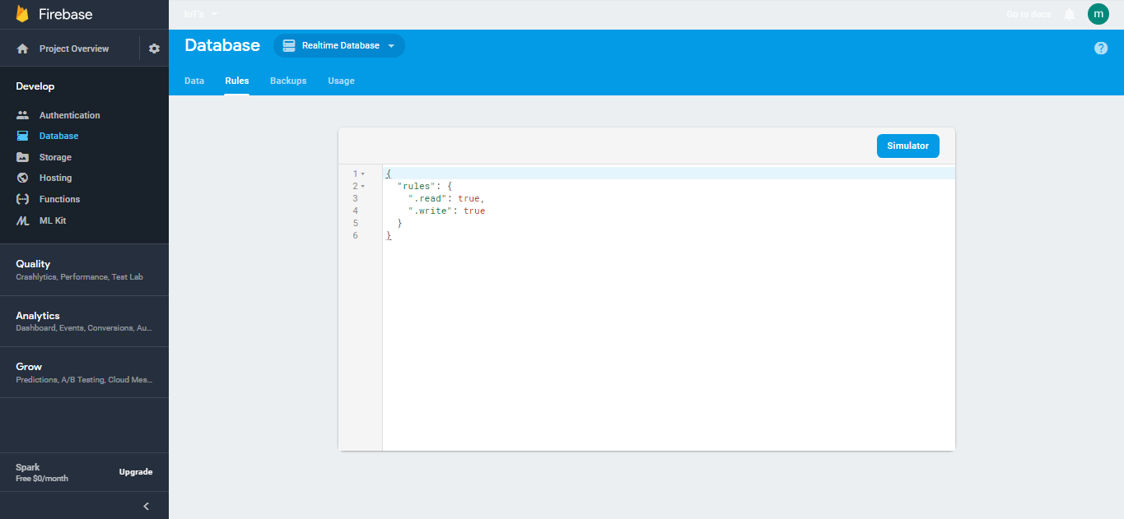

Open terminal in Raspberry pi

Type command

• git clone <https://github.com/szazo/DHT11_Python> and click enter

• Sudo pip install firebase_admin and click enter

Sending Temperature and humidity data to Firebase Database

import Adafruit_DHT

import RPi.GPIO as GPIO

from firebase_admin import db

import firebase_admin

from firebase_admin import credentials

import time

import dht11

sensor = DHT11

cred = credentials.Certificate('iot-s-864d5-firebase-adminsdk-im3fa-e547046cd1.json') # name of the downloaded json file

default_app = firebase_admin.initialize_app(cred, {'databaseURL' :

'https://iot-s-864d5.firebaseio.com/'}) # data base url of your project

root = db.reference()

GPIO.setmode(GPIO.BCM)

GPIO.setwarnings(False)

dht_device = dht11.DHT11(4)

def upload():

print("uploading")

root.child('vijay/savedvalue').push({'Temperature':str(result.temperature)+"cm",'Humidity':str(result.humidity)+"cm",})

root.child('latestvalue').set({'Temperature':str(result.temperature)+"cm",'Humidity':str(result.humidity)+"%" })

print(result.temperature)

while True:

result = dht_device.read()

time.sleep(1)

upload()

**MOBILE APP**

“Create accounts in MIT App Inventor 2”

Go to [http://appinventor.mit.edu/explore/#](http://appinventor.mit.edu/explore/)

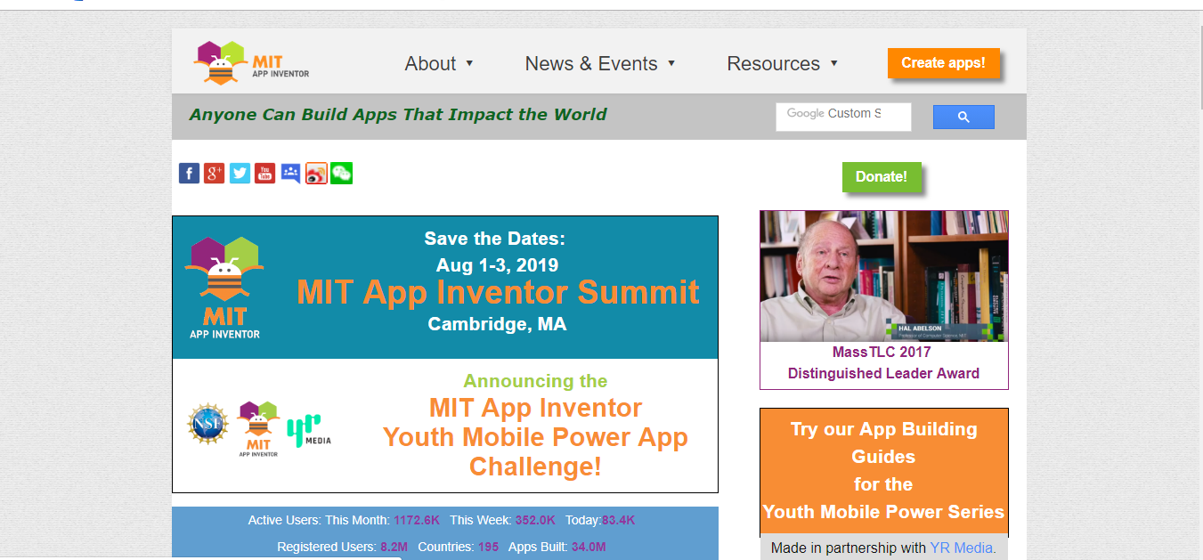

Then click on Create apps

Sign in through mail-id

Click on Allow

Click on I accept the terms of service

Click on Take survey later and continue



